KATHMANDU UNIVERSITY

DHULIKHEL KAVRE

**COEG-304:** Instrumentation and Control

Lab Sheet No. 4

**SUBMITTED BY SUBMITTED TO:**

Name: Ayush Kumar Shah Bibek Mahaseth Sir

Roll no: 44 Date of Submission:

Group: CE 3rd year 1st sem 31/01/2018

Level: UNG

**KATHMANDU School of Engineering**

**UNIVERSITY Department of Electrical & Electronics Engineering**

CONTROL ENGINEERING LABORATORY EXERCISE-III

**Time Response Analysis**

**3.1 First Order System**

**Example-1**

Consider the first-order model of the motion of a car. Assume the car to be travelling on a flat road. The horizontal forces acting on the car can be represented as shown in the figure below.

M

v

F

B

The differential equation representing the system is

$$M\frac{dv}{dt}=F-bv$$

Assume that:

F = 400N, M = 1000 kg and b = 40 N*sec/m

This system will be modeled in Simulink by using the system equation as above.

Or,

$$\frac{dv}{dt}=\frac{F-bv}{M}=\frac{F-40v}{1000}$$

***System response to Pulse Input***

Consider the response of the system if a pulse input is applied. This is approximately equivalent to the car's driver pressing and holding the pedal in a constant position for a specified period of time, and then releasing the pedal. To model a pulse input using SIMULINK, insert another Step block and a Sum block in the system as shown.

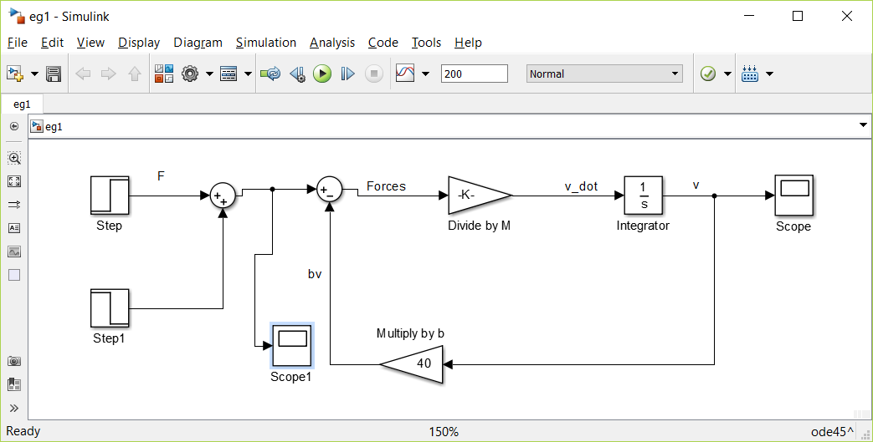

The parameters for the original "Step" block can be left as they were before. Modify the"Step1" block parameters to the following:

Step Time = 100

Initial Value = 0

Final Value = -400

These settings enable the "Step1" block to cancel out the input from the "Step" block starting at t= 100.To monitor the input of the system, F, we insert another scope into the model window as shown below:

Modify the simulation time (found by going to **Simulation,** then **Parameters**) to 200 seconds, and then run the simulation. After auto scaling the scopes recording the F and v signals, you should see graphs that look like:

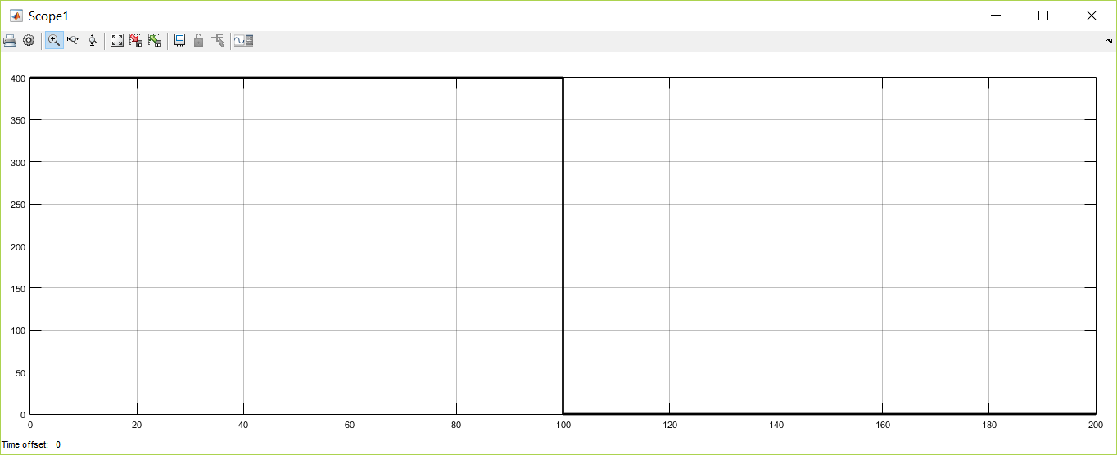

Fig: Graph of input F vs t

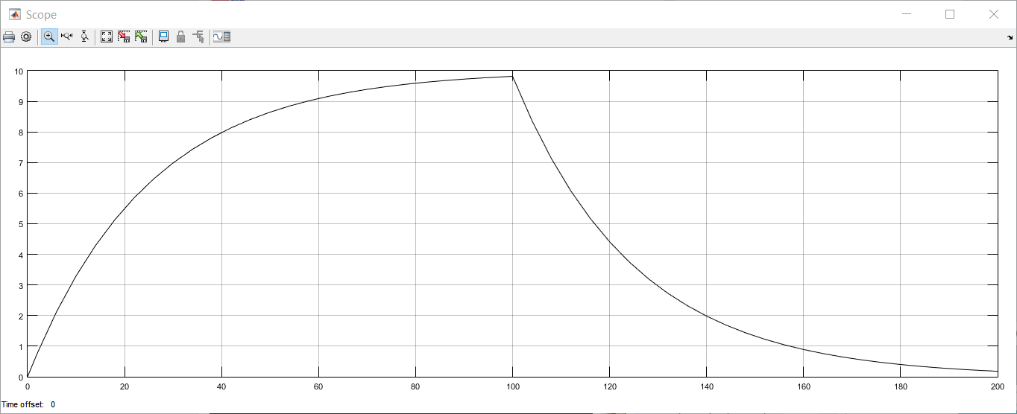

Fig: Graph of output v vs t

From the output plot the time constant of the system is 25 seconds. At t = 100 seconds in the simulation, the system is within 2% of its steady-state response to the original step input of 400 N. When F is instantaneously reduced to 0 at t = 100 seconds, it takes the system another 100 seconds (until t = 200 seconds) to respond to this new input.

***System response to Ramp Input***

Now apply a ramp input, F, to the system starting from rest. This is approximately equivalent to the car's driver steadily depressing the gas pedal as the vehicle accelerates from a stop light. To model this, insert a Ramp block from the Sources subfolder and connect it so that it produces the system input signal, F. Also, insert Scope blocks into the model to monitor the engine force, F, and the car's velocity, v.

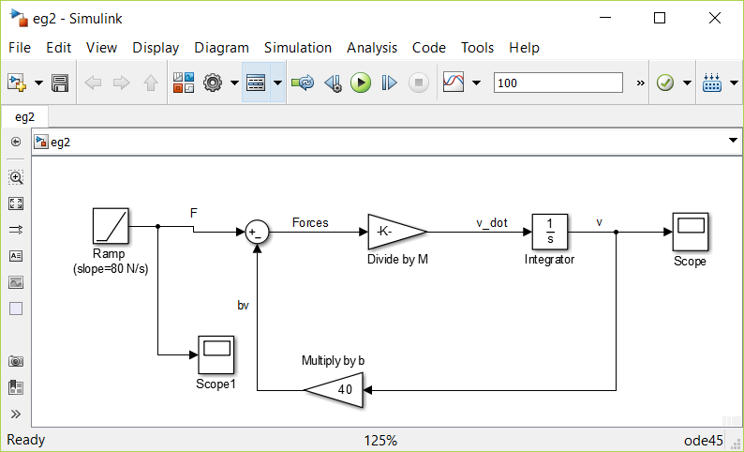

Double-click on the Ramp block to modify it and set the Slope equal to 80 N/s (you can leave the Start Time and Initial Output as 0). These settings cause the engine force to steadily increase 80 N every second, starting from F = 0 at t = 0. Also, set the simulation Stop Time to 100 seconds, and run the simulation. The simulation will result with the following input and output curves.

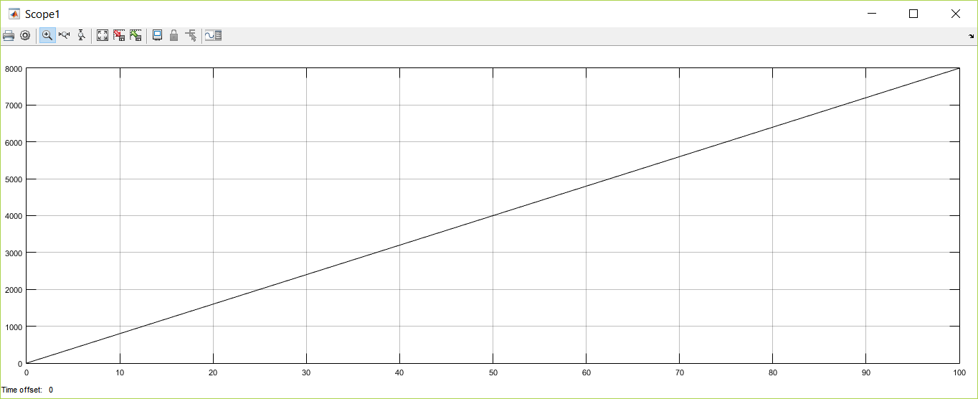

Fig: Graph of input F vs t

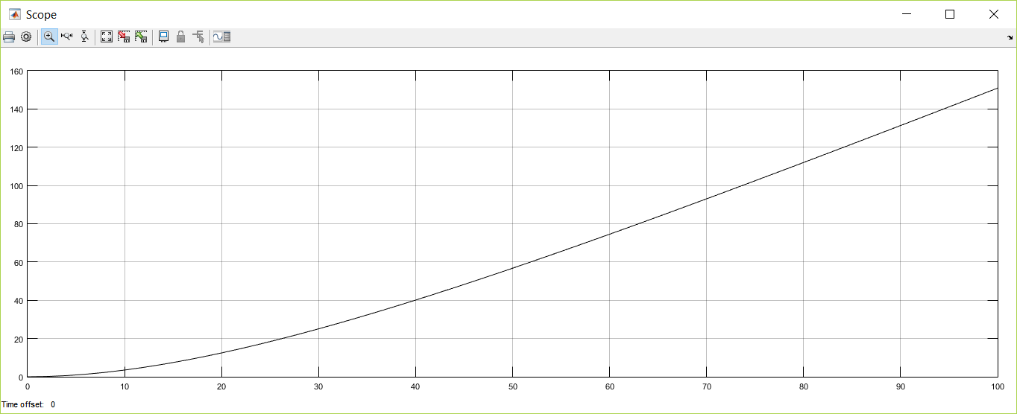

Fig: Graph of output v vs t

These plots show that if the input force of the engine, F, is increased steadily, the velocity of the car, v, will continue to rise, and thus does not approach a specific steady-state VALUE. Also note that as time passes, the velocity curve eventually settles into a straight line. So, the steady state response to the ramp input is linear, and it has a positive slope (i.e. the velocity of the system goes to infinity as time goes to infinity

***Ramp Input with Saturation***

Apply a ramp input to the system as before, with the following changes: The engine force, F, will not be allowed to exceed 2000 N. Thus, the system's input will appear as a ramp until its value reaches 2000 N. From that time forward, the saturated input will remain at 2000 N. This situation is similar to the car's driver, with the vehicle starting from rest, steadily pushing down on the gas pedal until it reaches the floor (i.e. the maximum force that the engine can provide), and then holding the pedal there for an indefinite time.

To model this input in Simulink, we insert a Saturation block right after the Ramp block in the model window. The system model will be as under:

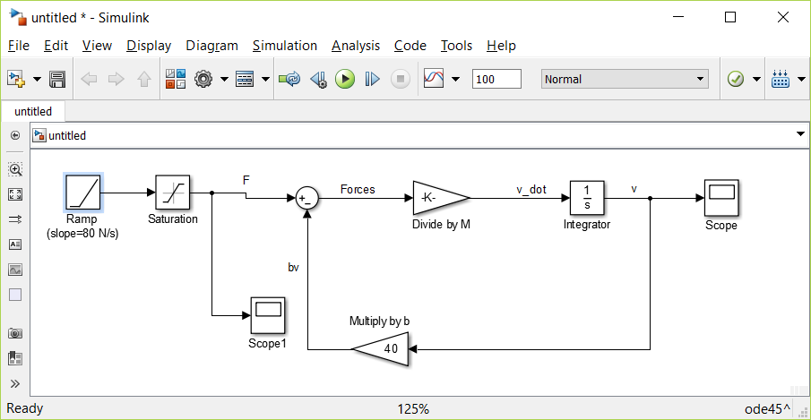

The Saturation block allows us to set an upper and lower limit for its input signal. If the signal to the block is between the minimum and maximum values we have set, the Saturation block passes it through unaltered. If the input signal is greater than the maximum, however, it outputs the set maximum value. Similarly, if the input signal is less than the minimum, the Saturation block simply outputs this user-defined minimum value. Double-click on the Saturation block to modify its parameters and change its Upper Limit to 2000 and its Lower Limit to 0. Now, run the simulation (change the Stop Time to 120 seconds), and view the F and v scope blocks.

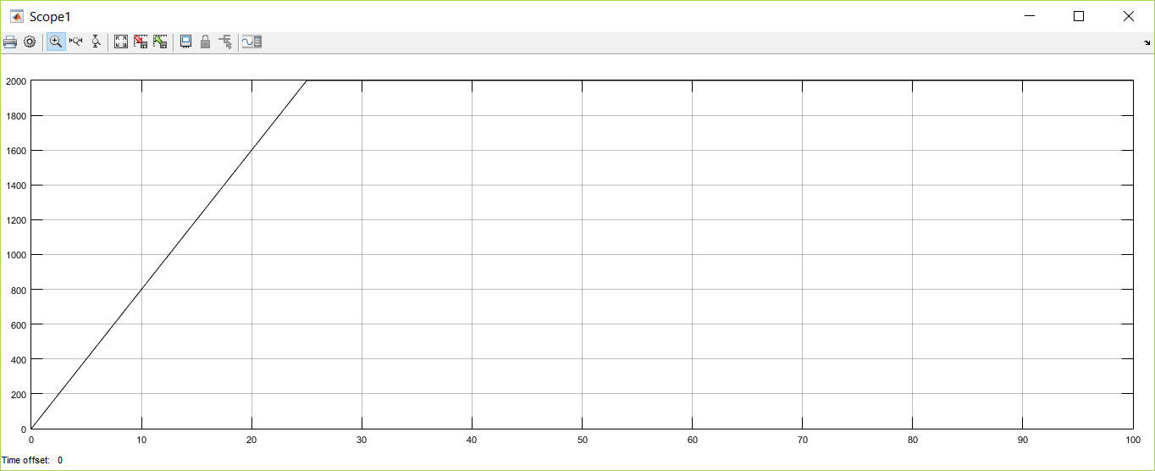

Fig: Graph of input F vs t

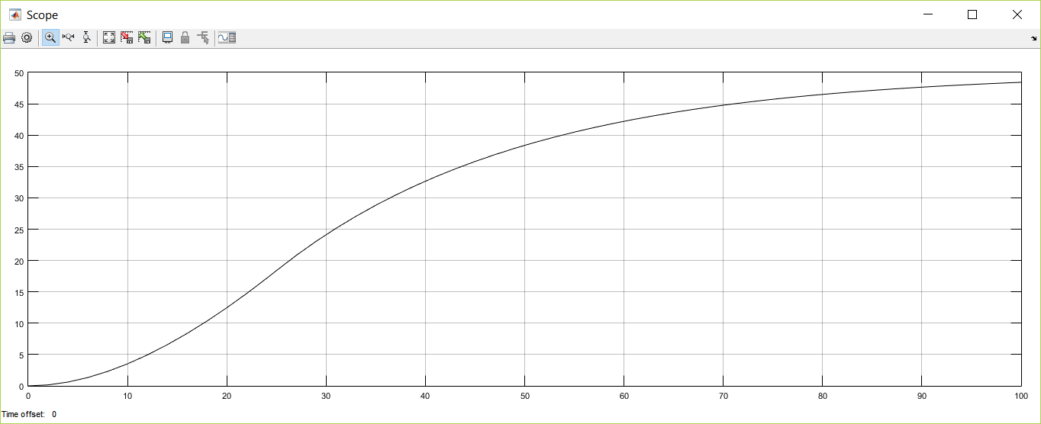

Fig: Graph of output v vs t

Note that the engine force plot, F, appears as a ramp input until it reaches 2000 N, and then stays at that maximum as time continues to pass. Also, up to about t = 25 seconds, the velocity response of the car, v, is identical to what it was for the ramp input we analyzed previously. Beyond that time, the two plots take on very different shapes, and in this example, the velocity appears to level off at 50 m/s (about 110 mph). This result is due to the input, F, reaching its saturation value of 2000 N at t = 25 seconds.

**3.2 Second order system**

**Example-2**

Consider a second order system as shown below:

M

x(t)

F(t)

K

b

The force equation of the system is

$$M\frac{d^{2}x}{{dt}^{2}}+b\frac{dx}{dt}+Kx=F(t)$$

This system will be modeled in Simulink by using the system equation as above.

$$\frac{d^{2}x}{{dt}^{2}}=\frac{1}{M}\left[F\left(t\right)-b\frac{dx}{dt}-Kx\right]$$

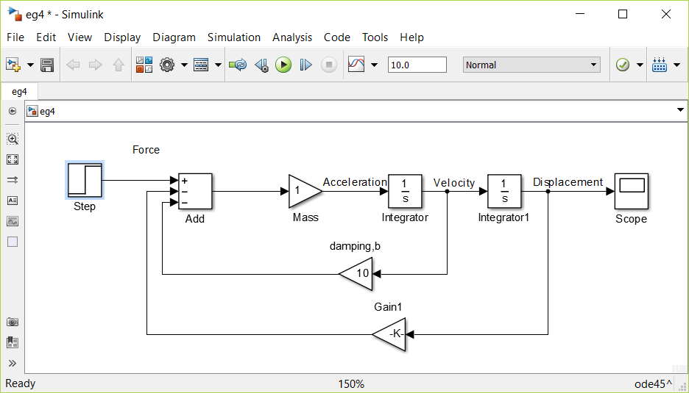

*System Response to Step Input*

Consider the following values for simulation: M =1; K = 500; b = 10. Also, for the step input consider step time = 0, Initial value = 0, Final value =1.

To simulate the system the applied input F is to be specified. The Step block must be modified to correctly represent the system. Double-click on it and change the Step Time to 0 and the Final Value to 10. The Initial Value can be left as 0, since the F step input starts from 0 at t = 0. The Sample Time should remain 0 so that the Step block's input is monitored continuously during simulation.

The output displacement x can be seen in the graph shown below

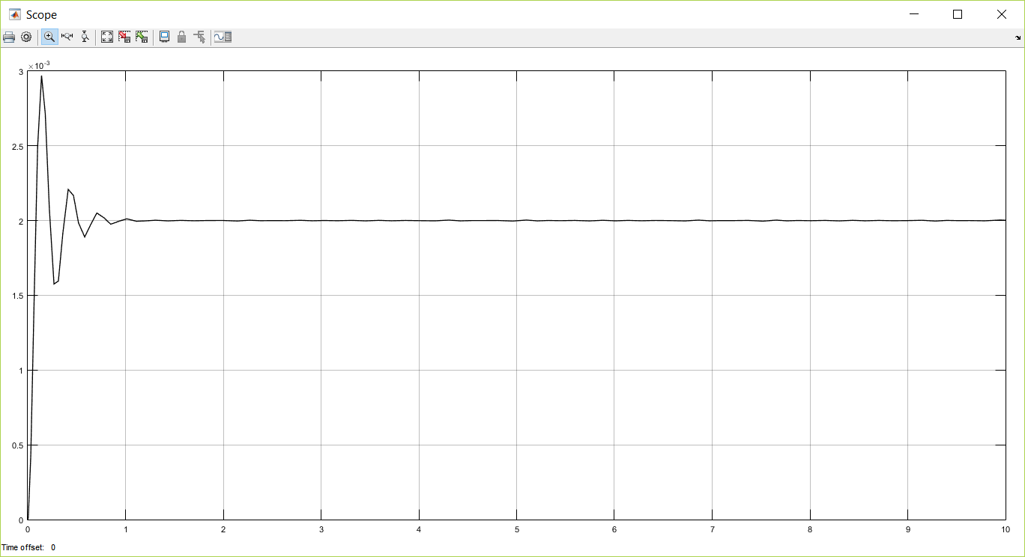

Fig: x vs t

The output response is an under-damped case.

Consider the same system with b = 44.7 and 100 and simulate the system.

1. For b = 44.7

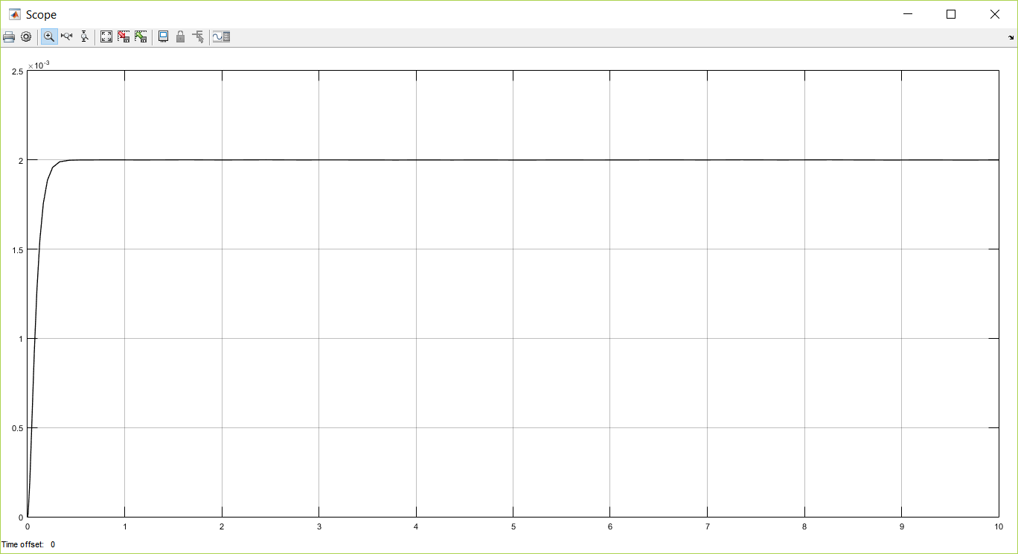

Figure (a) Case of a critically damped system

1. For b = 100

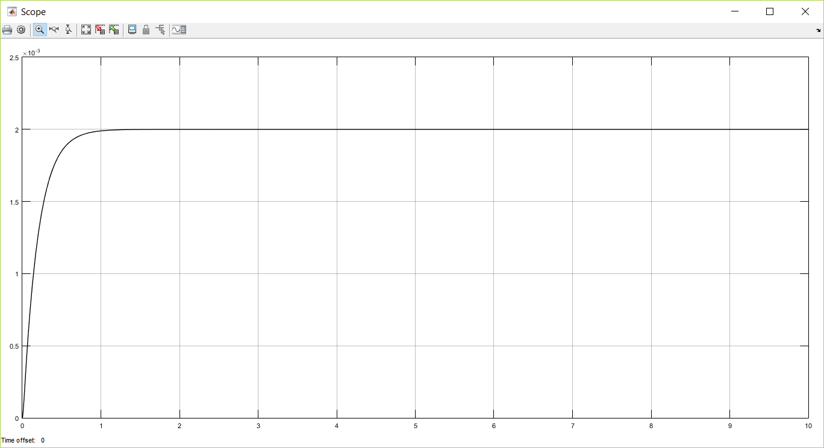

Figure (b): Case of an over-damped system

Now using Matlab code:

Let $x_{1}=x$ and $x_{2}=\frac{dx}{dt}$, then

$$\frac{{dx}_{1}}{dt}=x_{2}$$

$$\frac{{dx}_{2}}{dt}=\frac{1}{M}[f\left(t\right)-Bx_{2}-Kx_{1}]$$

**Code:**

m=1;

b=10;

k=500;

num=[0 0 1];

den=[m b k];

step(num,den);

hold on;

b=44.7;

den=[m b k];

step(num,den);

hold on;

b=100;

den=[m b k];

step(num,den);

text(0.2,0.0027,'b=10');

text(0.13,0.0015,'b=44.7');

text(0.2,0.001,'b=100');

hold off;

**Output:**

